Crank Arm and Tire Maintenance

Crank Arm Maintenance
Maintaining crank arm tightness is an important part of servicing your Adventure Works Cycle bicycle. These instructions apply to Adventure Works Cycles products 618, 619 and 620).
Both crank arms were tightened to the spindle at the Adventure Works Cycles factory. After riding the bicycle the first few times (or after the first 20 miles), make sure the crank arms are tight. If either crank arm has loosened during this break-in period, have it tightened by a bicycle service shop, because special tools are necessary.
CAUTION: Frequently check the tightness of the crank arms. Failure to maintain crank arm tightness may cause damage to the crank arm. Always have a professional bicycle service shop tighten the crank arms.

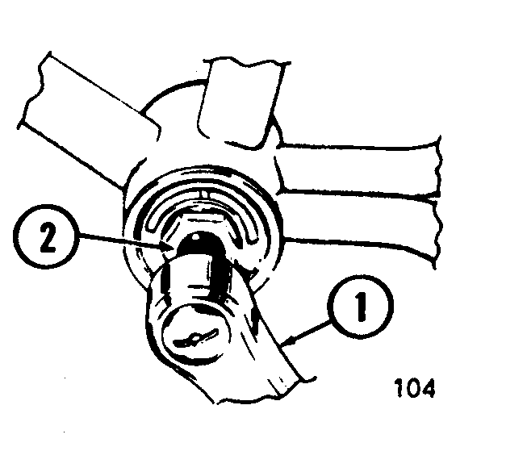

Tire Maintenance
All tires lose air slowly over time so it is important to check the tire inflation pressure before every ride. For extended storage, keep the weight of the bicycle off the tires.
WARNING: Do not ride or sit on the bicycle if either inner tube is under inflated. This can damage the tire and inner tube. Do not over inflate the tires. This can cause them to burst.
Use a hand or a foot pump to inflate the inner tubes. Service station meter-regulated air hoses are also acceptable. The correct inflation pressure is shown on the tire sidewall. If two inflation pressures are on the tire sidewall, use the higher pressure for on-road riding and the lower pressure for off-road riding. The lower pressure will provide better tire traction and a more comfortable ride.
Before adding air to any tire, make sure the edge of the tire (the bead) is the same distance from the rim, all around the rim, on both sides of the tire. If the tire does not appear to be seated correctly, release air from the inner tube until you can push the bead of the tire into the rim where necessary. Add air slowly and stop frequently to check the tire seating and the pressure, until you reach the correct inflation pressure.
Replace worn or defective tires and inner tubes immediately.

